

School of Computer Science Engineering and Information Systems

Fall Semester 2026-2027

Department of Software and Systems Engineering

SWE3004 - Software Design and Development Project

Review -1

Date: 13.8.2026
DocBot Advisor: A Retrieval-Augmented Generation (RAG) Based Conversational AI Assistant for Healthcare Document Question-Answering

22MIS0000 - Name
Under the Guidance of
Guide Name
Designation
SCORE

Guide Signature with date
Guide Name

Internal Examiner -1 Internal Examiner-2
Signature Signature

ABSTRACT:
DocBot Advisor is a Retrieval-Augmented Generation (RAG) based conversational assistant designed to help rural clinics, community health workers and individuals with limited digital literacy access reliable, document-grounded health information. Generic chatbots often hallucinate when queried on medical topics; DocBot Advisor addresses this by grounding every response in a knowledge base built from uploaded treatment protocols, drug manuals and disease FAQs, together with content pulled from websites and YouTube transcripts. The system uses LangChain document loaders (PyMuPDF, Unstructured, CSV, Web and YouTube loaders) to ingest heterogeneous sources, splits them with a RecursiveCharacterTextSplitter, converts the chunks into dense vectors using BGE sentence embeddings (BAAI/bge-small-en), and stores them in a persistent ChromaDB vector store. A Conversational Retrieval Chain, backed by an OpenRouter-hosted large language model (Mixtral-8x7B, GLM-4.5-Air or DeepSeek-V3) and a conversation memory buffer, retrieves the top-k most relevant chunks and generates context-aware, medically cautious answers through a rural-healthcare system prompt. The Streamlit front end also offers a quick disease-remedy lookup for common ailments, tailored to child or adult age groups, and an OCR pipeline (Tesseract, pdf2image) that extracts and analyses text from uploaded scanned documents or images. The result is an accessible, low-cost digital health assistant that keeps humans in the loop for serious symptoms.
200 Words & Keywords:
Keywords: Retrieval-Augmented Generation, LangChain, ChromaDB, BGE Embeddings, Conversational AI, Healthcare Chatbot, Optical Character Recognition, Streamlit, Vector Database, Large Language Model.

- INTRODUCTION:
Access to accurate, trustworthy health information is a persistent challenge in rural and semi-urban communities, where digital literacy is low and qualified medical staff are scarce. Large Language Models (LLMs) show strong conversational ability, but used directly for medical queries they are prone to hallucination because they answer from parametric memory rather than verified, local context. Retrieval-Augmented Generation (RAG) mitigates this by pairing an LLM with a retriever that fetches relevant passages from a trusted, up-to-date knowledge base before the model generates its answer. DocBot Advisor applies this RAG paradigm to healthcare: it lets a clinic upload its own treatment protocols, drug manuals and disease FAQs (as PDF, DOCX or CSV files), or point the system at trusted websites and YouTube videos, and then answers natural-language questions grounded in that material. The project combines a LangChain-based ingestion and retrieval pipeline, a persistent ChromaDB vector store, an OpenRouter-hosted LLM, and a Streamlit interface that also includes an age-aware quick-remedy lookup and an OCR module for scanned documents and photographs, making the assistant usable even by staff who cannot type long queries.
- PROBLEM STATEMENT:
Community health workers in rural clinics frequently rely on printed manuals, government advisories and scattered digital files that are difficult to search quickly during a patient consultation. General-purpose AI chatbots are not a safe substitute because they are not grounded in the clinic's own verified protocols and can produce plausible-sounding but incorrect medical guidance. There is, therefore, a need for a lightweight, document-grounded conversational assistant that can ingest a clinic's existing unstructured documents and external references, restrict its answers to that verified context wherever possible, remain usable by staff with limited digital literacy through simple, guided interactions, and clearly signal when a symptom requires professional medical attention rather than a home remedy.
- OBJECTIVES:
• To design a multi-source document ingestion pipeline that accepts PDF, DOCX and CSV uploads, website URLs and YouTube video links.
• To implement text chunking and BGE-based semantic embeddings with a persistent ChromaDB vector store so documents are embedded only once and re-used across sessions.
• To build a Conversational Retrieval-Augmented QA chain, with conversation memory, that answers user questions using retrieved context and a healthcare-specific system prompt.
• To provide an OCR-based document/image analysis pathway (Tesseract OCR, pdf2image) for users who can only submit a photograph or a scanned page.
• To offer a rule-based quick disease-remedy lookup, differentiated by child and adult age groups, for common ailments as a fast first response.
• To expose configurable retrieval parameters (chunk size, chunk overlap, top-k) through a Streamlit sidebar so the system can be tuned without code changes.
• To maintain a persistent, auditable log of system activity for debugging and monitoring.
- SCOPE OF THE PROJECT:
The current implementation covers the end-to-end pipeline from document ingestion to conversational answer generation for English-language text. It supports PDF, DOCX and CSV file uploads, website content, YouTube transcript retrieval, and OCR extraction from uploaded images or scanned PDFs. Retrieval and generation are powered by an OpenRouter-hosted LLM (configurable among Mixtral-8x7B, GLM-4.5-Air and DeepSeek-V3) rather than a fully offline model, and the vector store is persisted locally using ChromaDB so that already-processed documents do not need to be re-embedded on every run. The rule-based remedy lookup is limited to eight common, non-emergency ailments (cold, fever, headache, diarrhea, cough, typhoid, malaria and dehydration) and is a first-response aid rather than a diagnostic tool. The system does not perform medical diagnosis, does not replace a licensed healthcare provider, and directs users toward professional care for symptoms outside its scope. Multilingual support, mobile packaging and electronic health record integration are identified as extensions beyond the current scope.
- PROPOSED SYSTEM:
The proposed system, DocBot Advisor, is organised into four cooperating layers: a Presentation Layer built with Streamlit that manages user login, disease-remedy selection, chat interaction and document/image upload; a Document Ingestion Layer that uses LangChain loaders (PyMuPDFLoader, UnstructuredWordDocumentLoader, CSVLoader, WebBaseLoader and the YouTube Transcript API) to convert heterogeneous sources into a common Document format; a RAG Processing Layer that splits documents with a RecursiveCharacterTextSplitter (default chunk size 1000, overlap 50), embeds the chunks with BGE sentence embeddings, stores them in a persistent ChromaDB vector store, and retrieves the top-k most similar chunks for a LangChain ConversationalRetrievalChain backed by an OpenRouter LLM and a conversation memory buffer; and a Logging Layer that records pipeline events to logs/docbot.log. A rural-healthcare-focused system prompt instructs the LLM to ask clarifying questions, explain conditions in simple language, suggest affordable and practical remedies, and clearly flag red-flag symptoms that require urgent professional care. Section 9 illustrates this architecture, and Section 10 presents the corresponding UML use-case and class diagrams.
- LITERATURE SURVEY: (minimum 15 papers)
Follow APA format , Please discuss with your guide for the literature review format

S.NO | TITLE | MERITS | DEMERITS
1 | Diabetes and Heart Disease using Machine Learning. | This paper presents a new system for relating the significant features using machine learning models, which improves the diagnosis of multi-purpose disease prediction. The proposed system classifier that has sigmoid SVC, AdaBoost, and Decision tree algorithms. The paper also implements and presents the comparison of different models in terms of accuracy. | This paper needs a quality dataset. When using an Ada boost algorithm, noisy data and outliers should be avoided.  Feature Selection techniques are not properly explained.
2 | Heart Disease Prediction using Exploratory Data Analysis | In this paper, the risk factors that causes diabetic-heart disease is considered and predicted using various classification algorithm and the analysis is carried out using a publicly available data for heart disease and diabetes. In the result section, the visualized data shows that the prediction is accurate and predict the probability. | Inconclusive results, lack of standardized analysis, small sample population and outdated information that can adversely affect the authenticity of information.
3 | Diabetes Prediction using Machine Learning Algorithms | In this paper, we suggested a diabetic-heart disease prediction model for better classification that includes a few external factors that cause diabetes and tried to impose a gradient boosting and AdaBoost model for diabetic-heart disease prediction with the goal of increasing the accuracy of classification models heart along with regular factors. | They are unsteady, which means that a slight change in the data might result in a big change in the optimum decision tree's structure.
4 | Prediction of Heart Disease using Machine Learning Algorithms | This research intends to provide a detailed description of logistic regression and decision tree classifier that are applied in our research particularly in the prediction of Heart Disease and Diabetes. Some experiment has been conducted to compare the execution of predictive data mining technique on the same dataset, and the consequence reveals that logistic regression out performs over KNN and decision tree classification models. | Hardware dependent  Complex Algorithms are foreseen disadvantages of Neural Networks  Approximate Results
5 | Heart Disease Prediction Using Machine Learning | For the subset of the data, it builds as many trees as possible, then it aggregates the results of all the trees. This decreases the issue of overfitting in decision trees, as well as the variance, which raises accuracy. | This paper has not produce an accurate output for the classification models.  Random Forest creates a lot of trees and combines their outputs.
6 | Application of data mining methods in diabetes prediction | The strategies that are heavily reliant on data mining techniques can be used to forecast the risk of high blood pressure. In this study, we investigate the early diabetes prediction using five various data mining techniques. The experiment's findings demonstrate that ANNs (Artificial Neural Networks) offer the greatest accuracy compared to other methods. | Data preparation for neural network models needs careful attention for the future use of models.
7 | Diabetes and Heart Disease Prediction Using Machine Learning Algorithms | To predict the occurrence of heart disease as well as diabetes in patients who have it with outrageous exactness. In order to detect these disorders before they are coordinated, ML counts to be explicit and was applied to ANN, ELM, PCA, LASSO, ensemble learning, and SVM. On the basis of datasets for diabetes and heart disease, the accuracy of the aforementioned ML algorithms is assessed. | The skill of assembling is challenging to learn, and any poor decision might lead in a model with worse prediction accuracy than an individual model.
8 | Heart Disease Diagnosis and Prediction Using Machine Learning and Data Mining Techniques | It has a successful system for assessing missing information and keeps up accuracy when a vast extent of the data is missing, it has methods for adjusting error in class populace unequal data sets. | It does not oblige models or parameters to choose aside from the quantity of indicators to pick at arbitrary at every node.
9. | Practicability of Heart Attack Prediction using Machine Learning | This paper provides the unique strategy for identifying relevant characteristics using data mining algorithms, which increases the quality of metabolic syndrome prognosis. Possible variations of characteristics and many well-known classification methods are used to establish the statistical model. | In comparison to other current techniques, they suggested  hybrid method produces results of 86.8% for F measure
10 | Heart Disease Prediction System Using Data Mining and Hybrid Intelligent Techniques | This paper produces an automated system which predicts the heart disease accurately based on the symptoms according to gender/age and domain knowledge of experts in the field at the lowest cost. | Classification via clustering achieves poor compared to other two methods. Author intends to extend the work for predicting the intensity of the disease using fuzzy methods.
11 | Modeling and design of evolutionary neural network for heart disease detection | This paper indulge the design of diagnosis system for heart disease detection will become easy, cost effective, reliable and efficient. | Scientific data also demonstrates that socio-economically poor populations are now primarily affected by CVD and associated risk factors, which evicts them from their homes.
12 | Machine Learning Classification Techniques for Heart Disease Prediction | In We present an overview of the machine learning classification methods that have been suggested to aid medical practitioners in the diagnosis of heart disease in this work. The most popular classification algorithms for the diagnosis of heart disease. Finally, we examine research studies that are representative of this field's use of machine learning classification approaches. Also, a thorough tabular comparison of the papers surveyed is provided. | The mortality rate and total complications can be reduced by early identification of heart disorders.
13 | Heart Disease Prediction using Artificial Intelligence | The patient and the doctor provided the project's input information. Heart illness is then analyzed using various AI algorithms using the doctor's inputs. The results are now compared to those of other models that have been used in the same area and are determined to be superior. | Accuracy cannot be guaranteed by a computerized system alone, and warehouse data is only as reliable as the data input that produce
14 | A Computational Intelligence Method for Effective Diagnosis of  Heart Disease using Genetic Algorithm | The technology is more useful when we come across the patients suffer with more than one type of disease of same category. In such cases the information obtained from the patient may be interrelated with the signs and symptoms in the medical diagnosis where the physicians may not be able to diagnose accurately. | The problem of uncertainty is due to different reasons which includes patients not describing accurately what has happened to them or how they suffer, doctors and nurses cannot explain exactly what they detect, some degrees of error in the laboratory reports, inability of the medical researchers not precisely characterizing how diseases modify the normal functioning of the body and no one can precisely determine ones prognosis.
15 | Prediction of Diabetes Using Artificial Neural Network Approach | Using test data from a sample population, this model performs at 92% accuracy in predicting the risk of diabetes. | To function, the neural network needed training. For large neural networks, a lot of processing time was required.

[6.1] FINDINGS IN LITERATURE SURVEY:
The reviewed literature (predominantly machine-learning based prediction of diabetes and heart disease) consistently shows that model accuracy is highly sensitive to data quality, feature selection and the reliability of the source dataset, and that even high-performing models struggle to explain their predictions to non-expert users. These recurring issues — the need for verified, high-quality context and for output that a non-specialist can trust and act on — directly motivate the design choices made in the DocBot Advisor project. Rather than training a bespoke predictive model, DocBot Advisor grounds every answer in the clinic's own verified documents through Retrieval-Augmented Generation, and pairs this with a system prompt that explains conditions in plain language and always defers to a professional for serious or ambiguous symptoms, addressing the interpretability and reliability gaps highlighted across the surveyed papers.
[7.] METHEDOLOGY:
The system was developed iteratively, module by module, following the layered architecture described in Section 9:
1. Requirement analysis: identified two user personas — patients/clinic staff and administrators/doctors — and the document types each would supply (protocols, drug manuals, FAQs, websites, YouTube videos).
2. Ingestion module: implemented dataloader.py to load default and uploaded PDF, DOCX and CSV files, website content and YouTube transcripts into a common LangChain Document format.
3. Chunking and embedding: implemented the setup_qa_chain() function in llm.py, which splits documents with a RecursiveCharacterTextSplitter (chunk size 1000, overlap 50) and embeds the chunks with HuggingFaceBgeEmbeddings (BAAI/bge-small-en) before persisting them in a ChromaDB vector store (chromadb_store/).
4. Retrieval-augmented generation: configured a ConversationalRetrievalChain with a top-k retriever, ConversationBufferMemory and a custom rural-healthcare system prompt, using an OpenRouter-hosted chat model as the generator.
5. User interface: built streamlitui.py and app.py to provide sidebar configuration (chunk size, overlap, top-k, file/URL inputs), a login form, an age-aware disease-remedy quick lookup (input.py), a chat interface, and an OCR-based document/image analysis flow (pytesseract, pdf2image).
6. Logging and testing: added logging (logs/docbot.log) for traceability and performed functional testing of each module (ingestion, embedding, retrieval, chat, OCR) before integration testing of the full pipeline.
[8.] SOFTWARE REQUIREMENTS: Functional and Non Functional Requirements
Functional Requirements
• FR1: The system shall allow a user to log in with name, age and mobile number to personalise responses (e.g., child vs. adult remedy).
• FR2: The system shall allow users to upload PDF, DOCX and CSV files, and to enter website and YouTube URLs as knowledge sources.
• FR3: The system shall chunk and embed ingested documents and store them in a persistent ChromaDB vector store, with configurable chunk size, overlap and top-k retrieval.
• FR4: The system shall provide a conversational chat interface that answers user questions using retrieved context and a healthcare-specific system prompt.
• FR5: The system shall provide a quick-lookup of remedies for common diseases, filtered by symptoms and the user's age group.
• FR6: The system shall extract text from uploaded images or scanned PDFs using OCR and allow the extracted text to be analysed by the QA chain.
• FR7: The system shall log key pipeline events (document loading, chain setup, errors) to a persistent log file.
Non-Functional Requirements
• NFR1 (Usability): The interface shall be a single-page Streamlit application usable without coding knowledge, with sidebar sliders for configuration.
• NFR2 (Performance): Retrieval shall be tunable via a top-k parameter (1–10) to balance response latency against answer relevance.
• NFR3 (Reliability): The vector store shall persist across sessions so that previously processed documents are not re-embedded unnecessarily.
• NFR4 (Portability): The application shall run on any system with Python 3.10+ and the packages listed in requirements.txt.
• NFR5 (Security): API keys used to access the LLM provider shall be kept outside of version-controlled source code in a production deployment.
• NFR6 (Maintainability): The codebase shall remain modular (separate loader, LLM-chain and UI modules) to simplify future extension to new document types or LLM providers.
[9.] SYSTEM ARCHITECTURE:
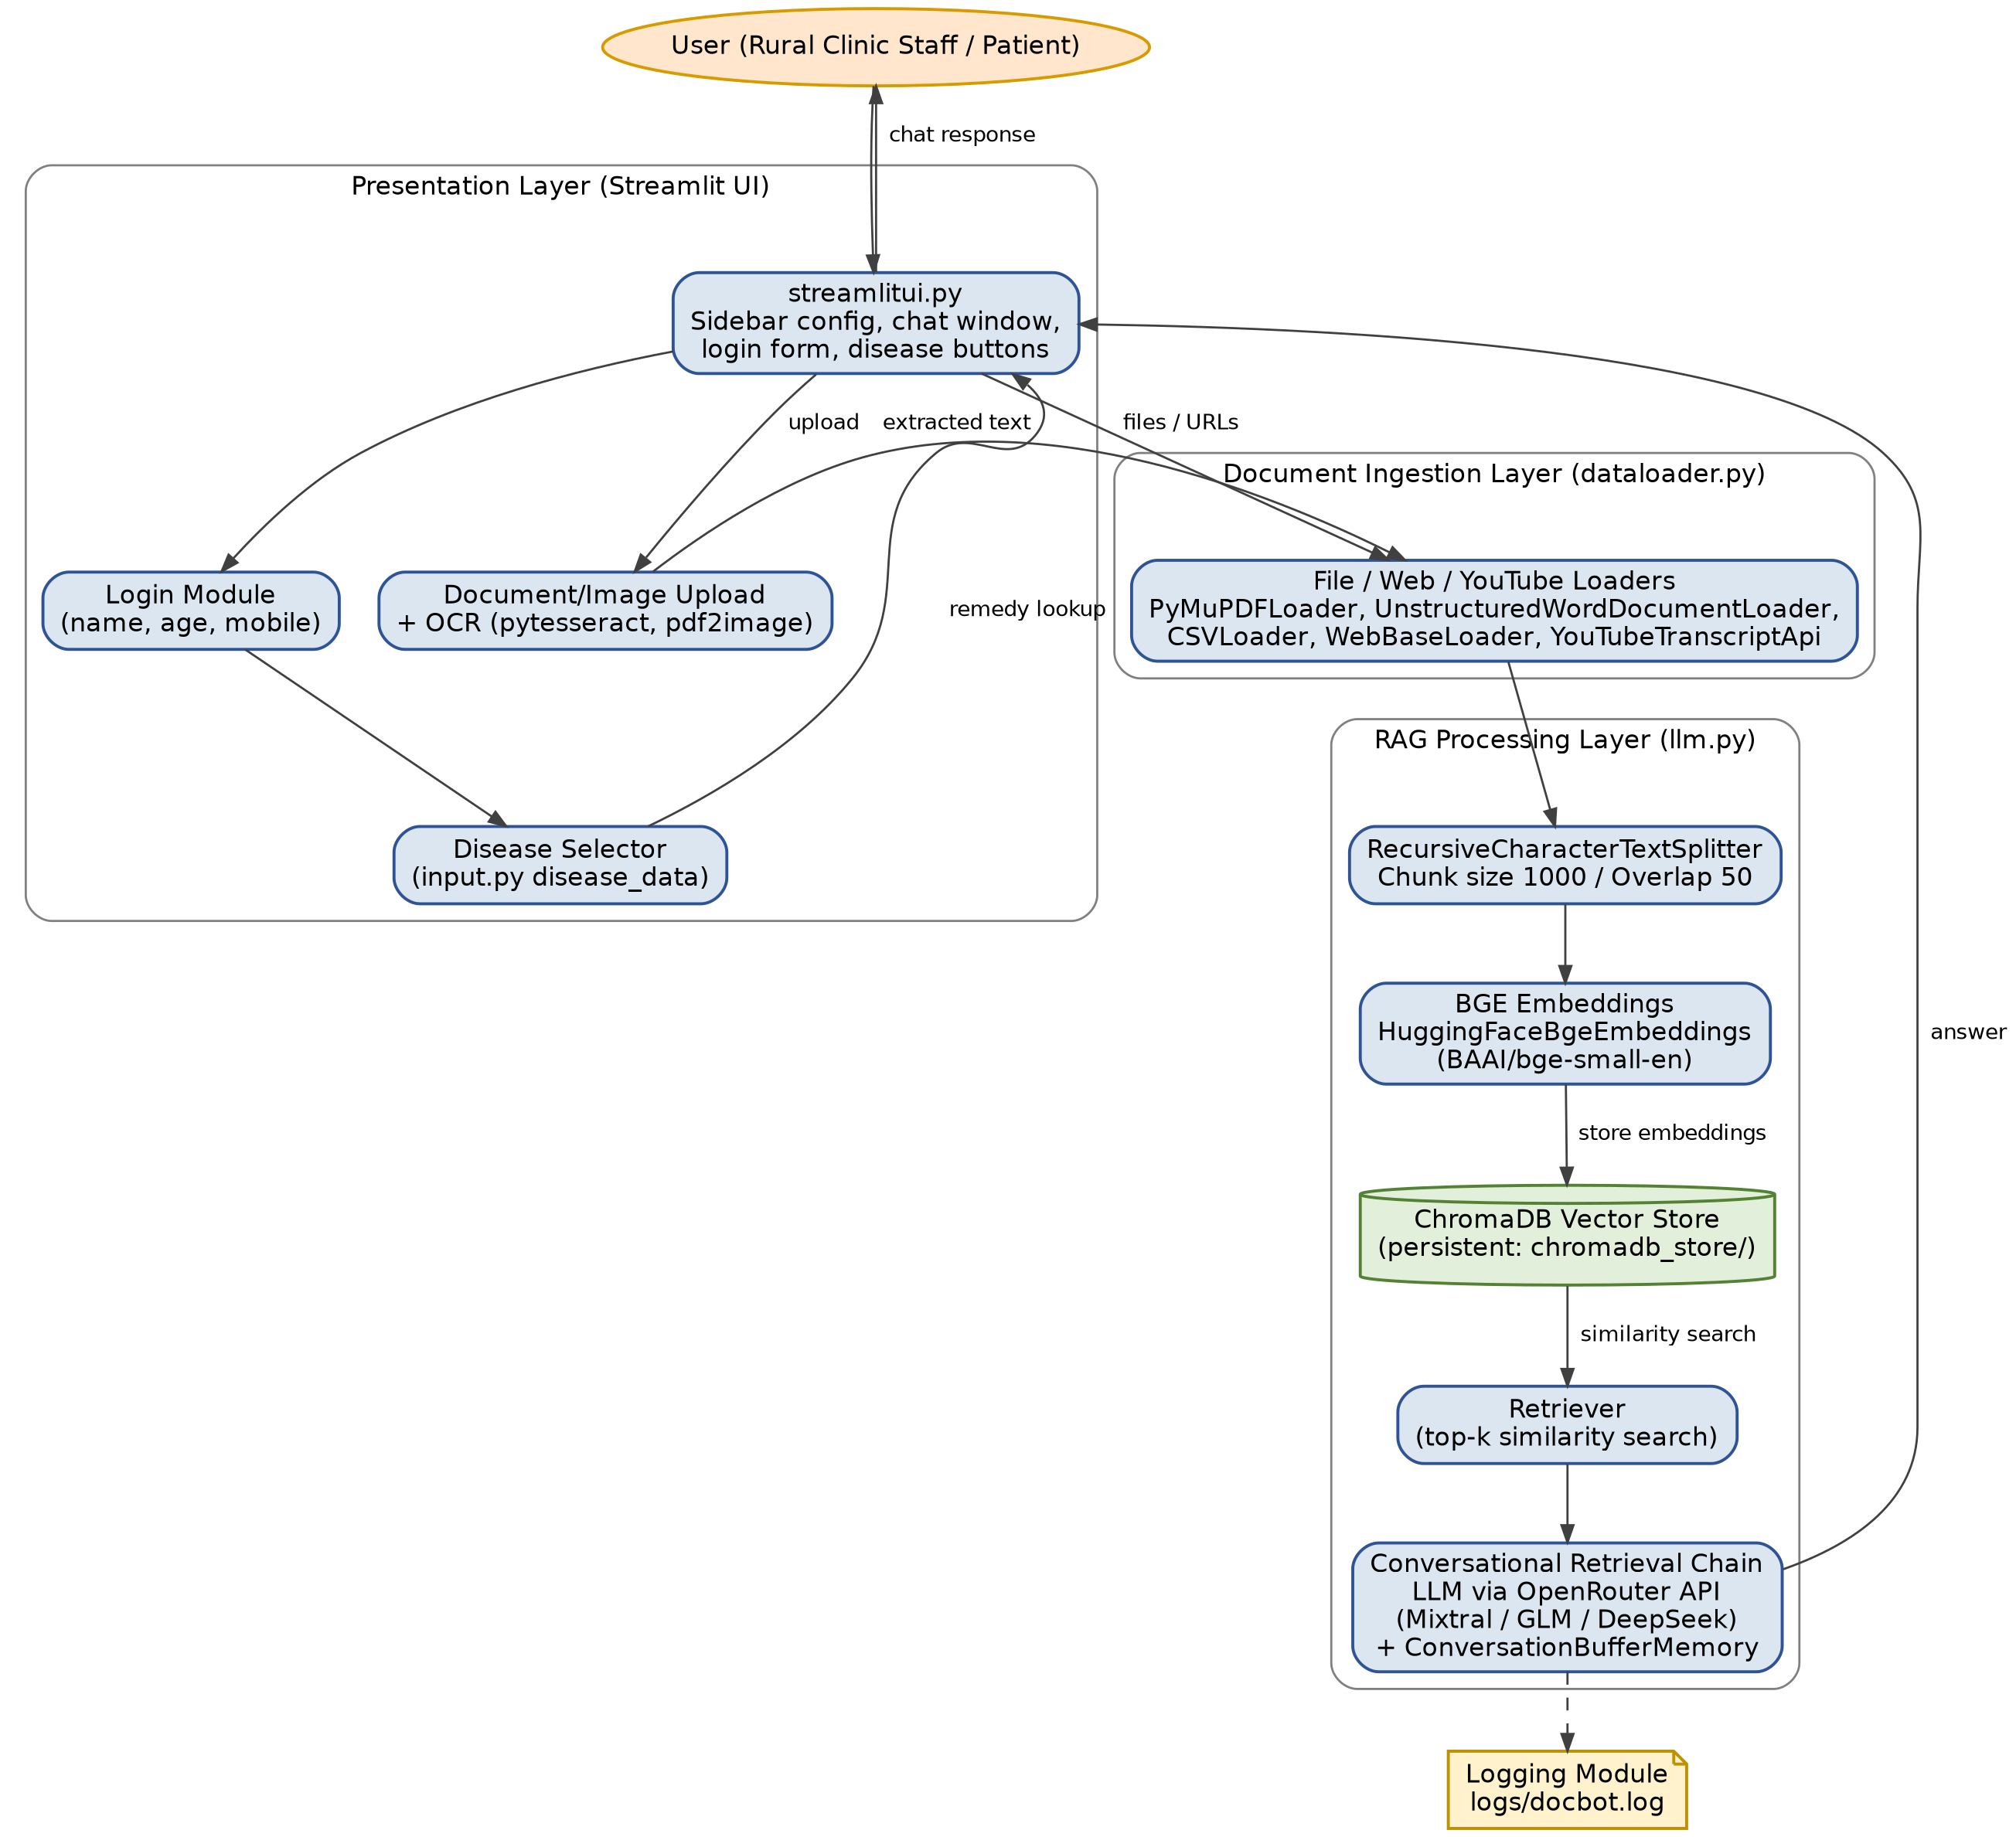

Fig. 9.1 System Architecture

[10]. UML DIAGRAMS:
This section presents the Use Case diagram, showing how the two user roles (Patient/Clinic Staff and Admin/Doctor) interact with DocBot Advisor, and the Class diagram, showing the main modules, their attributes/operations, and how they collaborate.
Use Case & Class Diagrams are compulsory
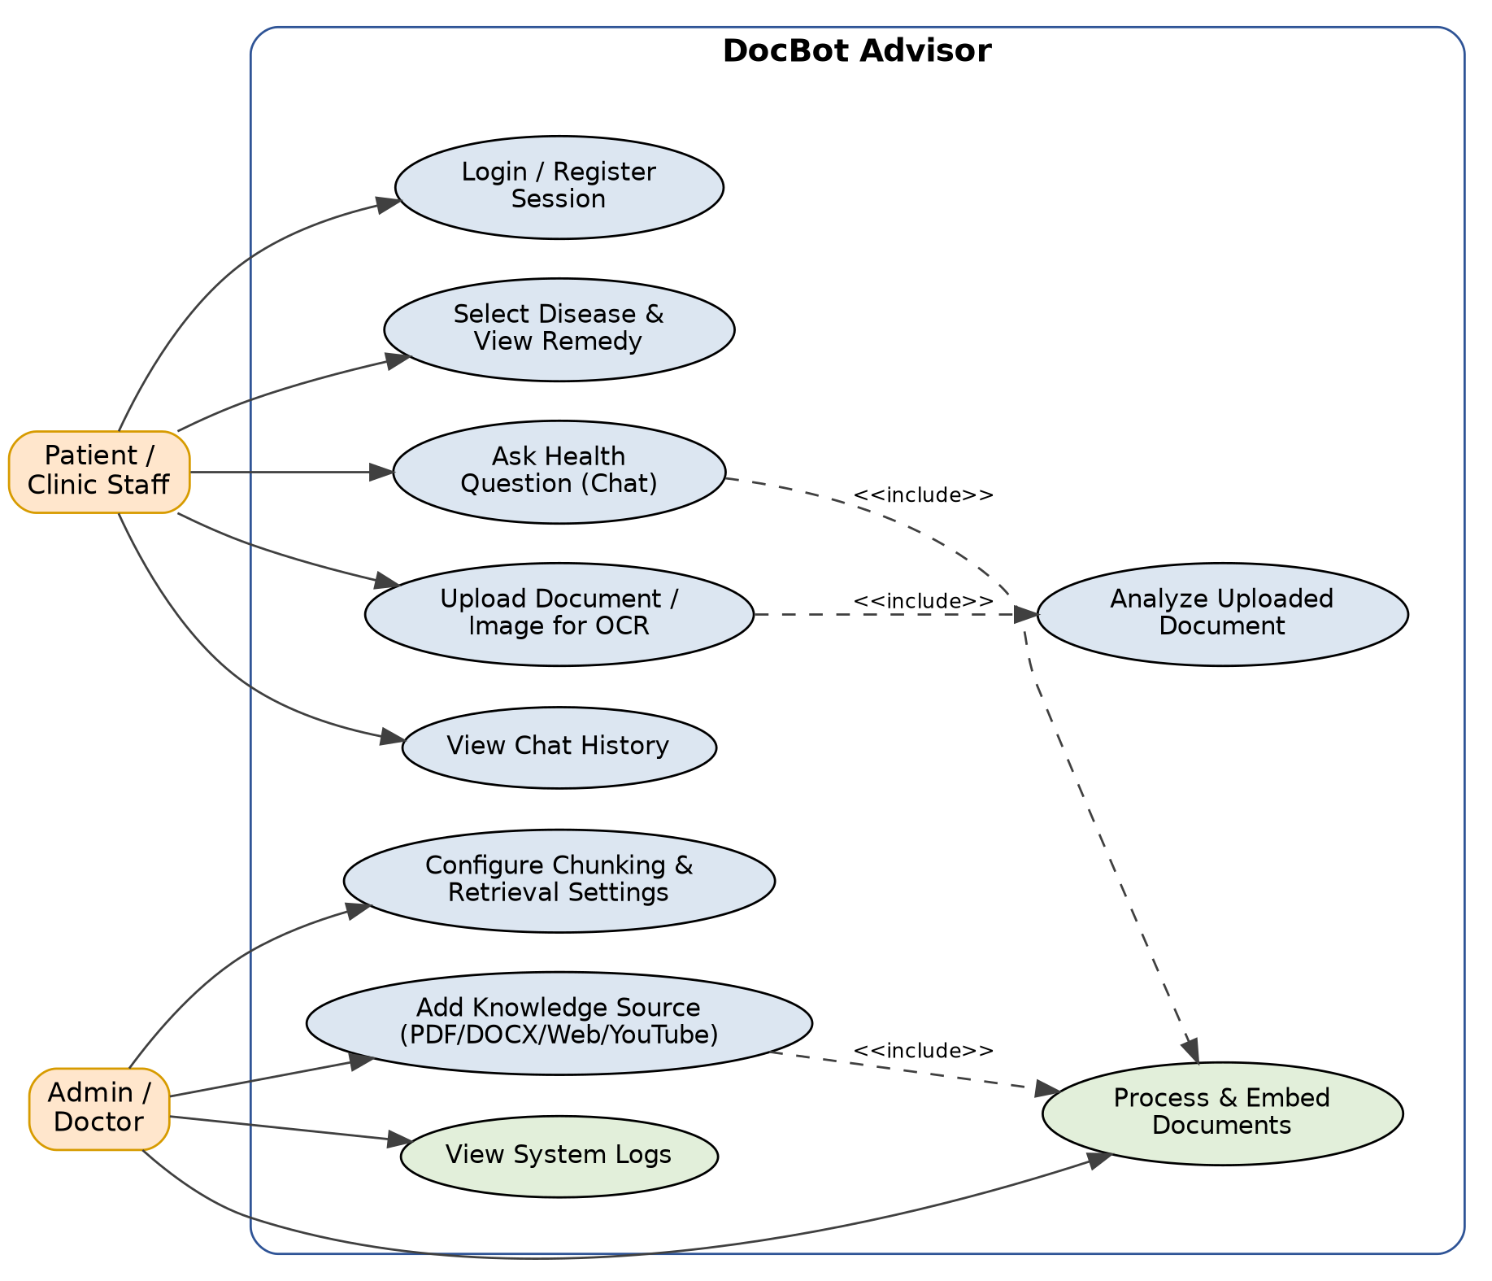
Fig. 10.1 Use Case Diagram — DocBot Advisor
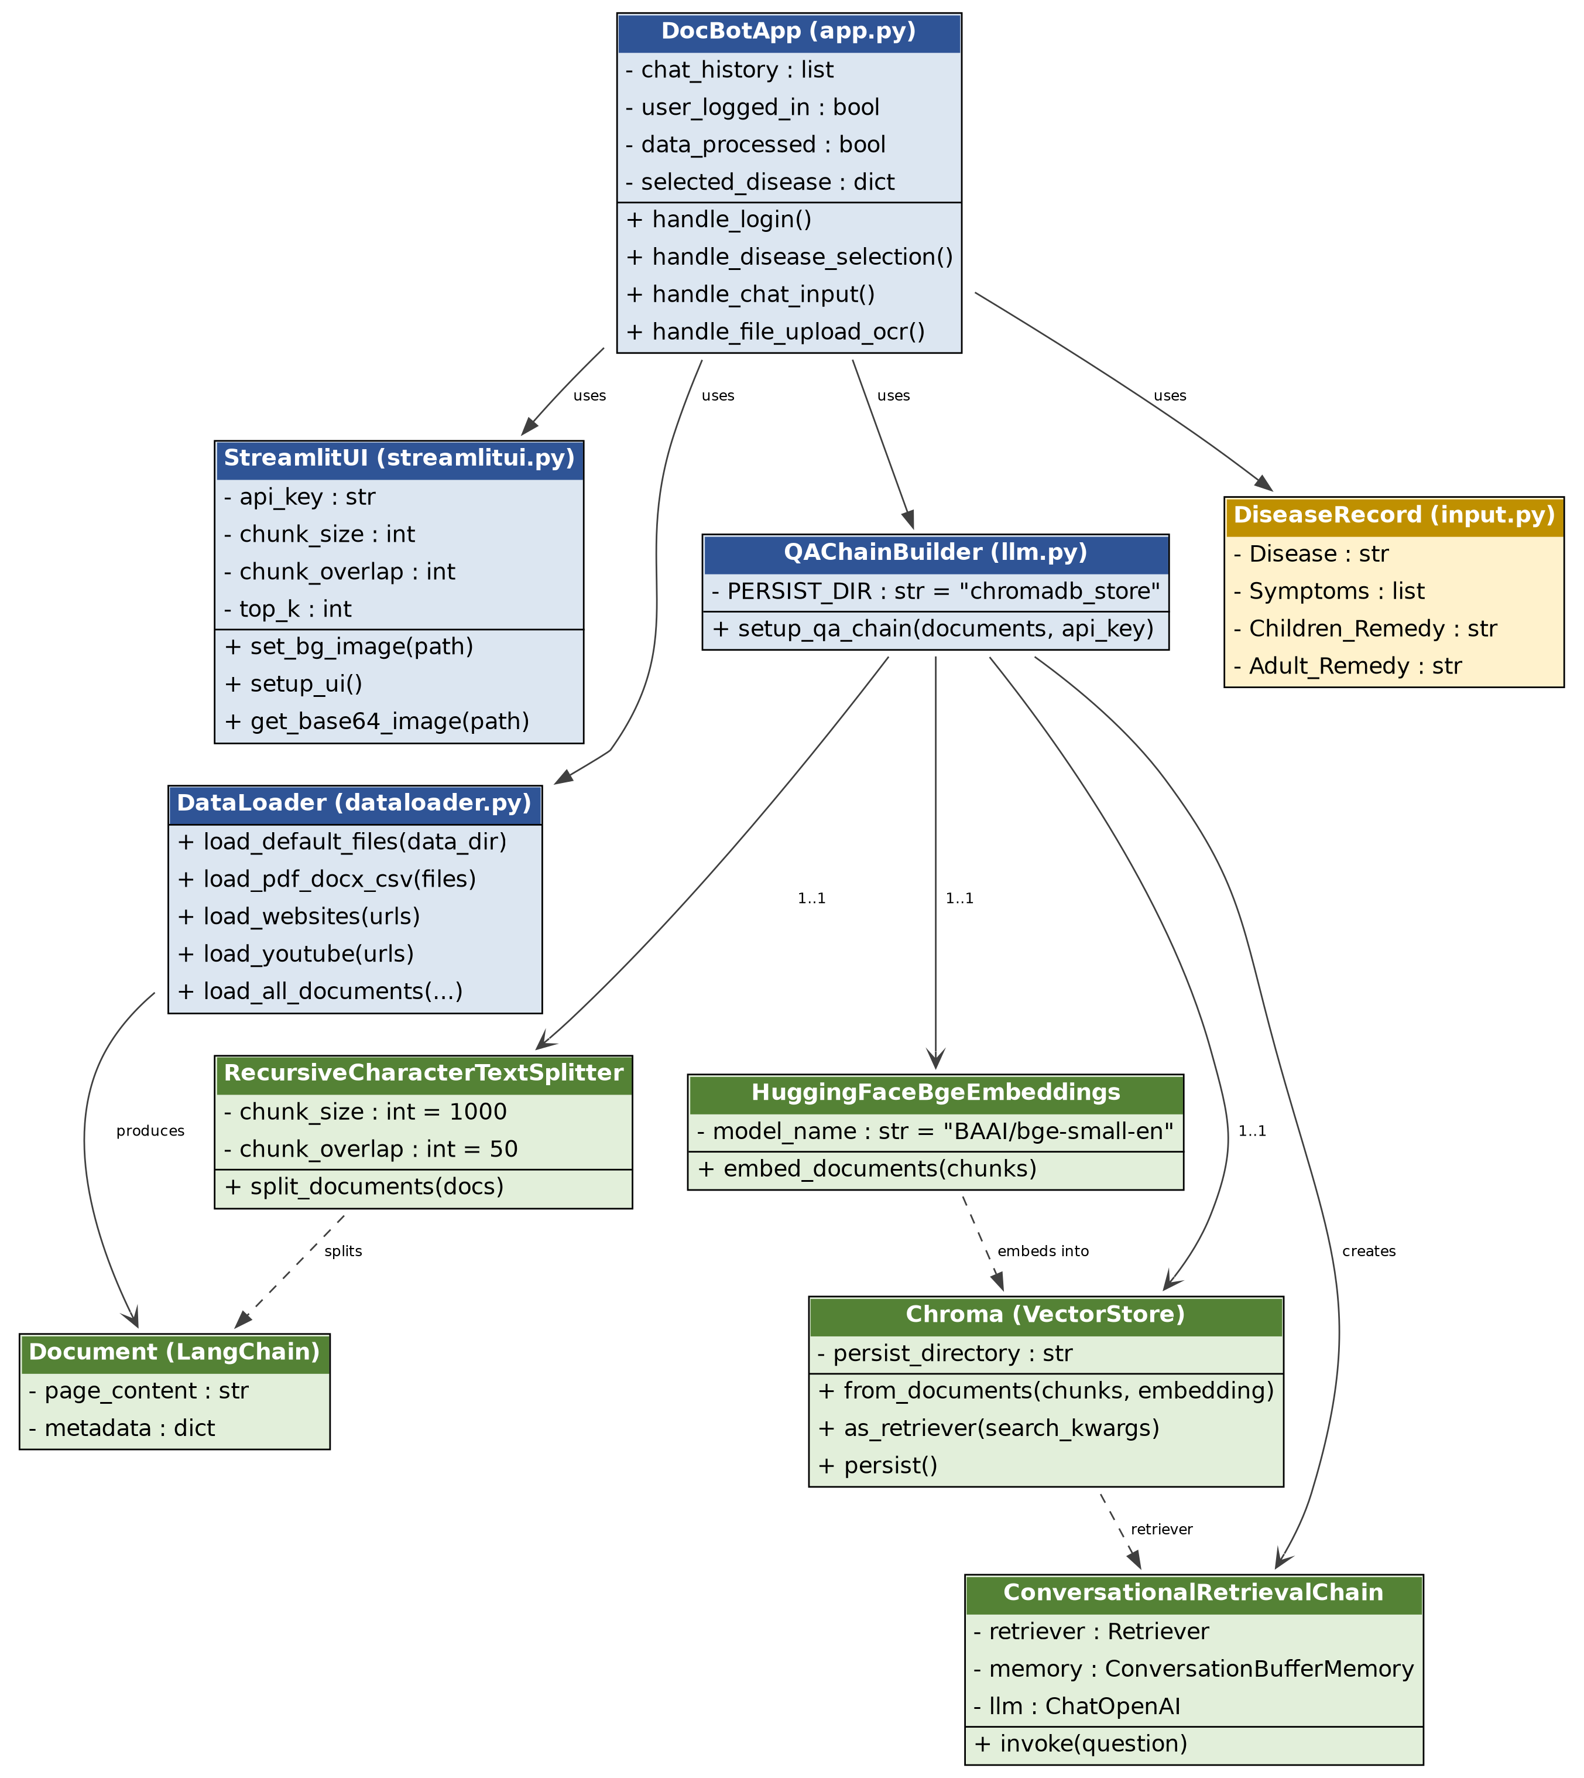
Fig. 10.2 Class Diagram — DocBot Advisor
[11] SUMMARY:
DocBot Advisor demonstrates a practical Retrieval-Augmented Generation pipeline that turns a clinic's own documents, together with external web and video sources, into a conversational healthcare assistant. By combining LangChain document loaders, BGE embeddings, a persistent ChromaDB vector store and an OpenRouter-hosted LLM behind a safety-conscious system prompt, the system reduces hallucination risk compared to a generic chatbot while remaining accessible to non-technical users through a configurable Streamlit interface, an age-aware quick-remedy lookup and an OCR pathway for scanned documents. This review (Review-1) establishes the ingestion, embedding, retrieval and chat pipeline along with the supporting UML design; subsequent phases will focus on expanding the literature base specific to RAG-driven healthcare assistants, strengthening evaluation of answer accuracy and retrieval relevance, and hardening the system for real-world clinic deployment (e.g., secure API-key handling, multilingual support).

REFERENCES: (minimum 15 papers)

- Bianca de Almeida-Pititto, Patrícia M. Dualib, Lenita Zajdenverg, JoanaRodrigues Dantas,Filipe Dias de Souza , Melanie Rodacki and Marcello Casaccia Bertoluci on behalf of Brazilian Diabetes Society Study Group (SBD), “Severity And Mortality Of COVID 19”, In Patients With Diabetes, Hypertension And Cardio vascular Disease: A Meta-analysis,Diabetology & Metabolic Syndrome Research, (2020)
- R. Indrakumari, T. Poongodi, Soumya Ranjan Jena, “Heart Disease Prediction using Exploratory Data Analysis, International Conference” on Smart Sustainable Intelligent Computingand Applications under (ICITETM 2020)
- Senthilkumar Mohan 1, Chandrasegar Thirumalai1, And Gautam Srivastava 2,3, (Member,IEEE), “Effective Heart Disease Prediction Using Hybrid Machine Learning Techniques”,(IEEE ACCESS)
- Aishwarya Majumdar, Dr. Vaidehi , “Diabetes Prediction using Machine Learning Algorithms, International Conference” On Recent Trends In Advanced Computing (2019, ICRTAC2019)
- Emma Barron, Chirag Bakhai, Partha Kar, Andy Weaver, Dominique Bradley, Hassan Ismail, Peter Knighton, Naomi Holman, Kamlesh Khunti, Naveed Sattar, Nicholas J Wareham,Bob Young, Jonathan Valabhji, Associations of type 1 and type 2 diabetes with COVID-19 related mortality in England: a whole-population study, (Lancet Diabetes Endocrinol 2020)
- Quan Zou, Kaiyang Qu , Yamei Luo, Dehui Yin, Ying Ju,Hua Tang, “Predicting Diabetes Mellitus With Machine Learning Techniques,” Bioinformatics and Computational Biology(Frontier Genetics Journal, 2018)
- Md. Kamrul Hasan , Md. Ashraful Alam , Dola Das, Eklas Hossain, (Senior Member, IEEE), And Mahmudul Hasan, “Diabetes Prediction Using Ensembling of Different MachineLearning Classifiers”, (IEEE ACCESS 2020)
- Jyoti Soni, Ujma Ansari, Dipesh Sharma, Sunita Soni, Predictive Daa Mining for Medical Diagnosis”, International Jourmal of Computer Applications, (Volume 17, #8,2011)
- Himanshu Sharma, MA Rizvi, “Prediction of Heart Disease using Machine Learning Algorithms: A Survey”,International Journal on Recent and Innovation Trends in Computing and Communication (2016)
- Baban U. Rindhe, Nikita Ahire, Rupali Patil, Shweta Gagare, Manisha Darade, “Heart Disease Prediction Using Machine Learning”, IJARSCT, (2021)
- Nabaouia Louridi, Samira Douzi, Bouabid El Ouahidi, “Machine Learning-Based Identifcation Of Patients With A Cardiovascular Defect”, Journal of Big Data (2021)
- Dhai Eddine Salhi, Abdelkamel Tari, M-Tahar Kechadi, “Using Machine learning for heart disease prediction”, researchgate.net.
- Zaibunnisa L. H. Malik, Momin Fatema, Nikam Pooja, Gawandar Ankita, 2021, Heart Disease Prediction using Artificial Intelligence, INTERNATIONAL JOURNAL OF ENGINEERING RESEARCH & TECHNOLOGY (IJERT) NREST – 2021 (Volume 09 – Issue 04),
- Kumar, P. & Anand, D.. (2016). A Computational Intelligence Method for Effective Diagnosis of Heart Disease using Genetic Algorithm. International Journal of Bio-Science and Bio-Technology. 8. 363-372. 10.14257/ijbsbt.2016.8.2.34.
- Shifei Ding, XinzhengXu, Rubie, “Extreme learning machine and its applications.”, Neural Comput&Applic, IJCSIS, (2018) 25:549–556 https://doi.org/10.1007/s00521-013-1522-8

